# Goal

Access VNet resources from Pods in your cluster. We will access the following

1. A website running on a VM in the hub VNet that is peered to the cluster (Spoke) VNet.
2. Retrieve a blob from a storage account tied to your cluster subnet and protected by Service Endpoints

**Note: Run the lab from the same directory where you found this instructions file**

# Steps

## Access a Website in your VNet

The website is running in a VM in the hub VNet. It is called “C*-VM01” where * represents your company no. See sample for Company59 below

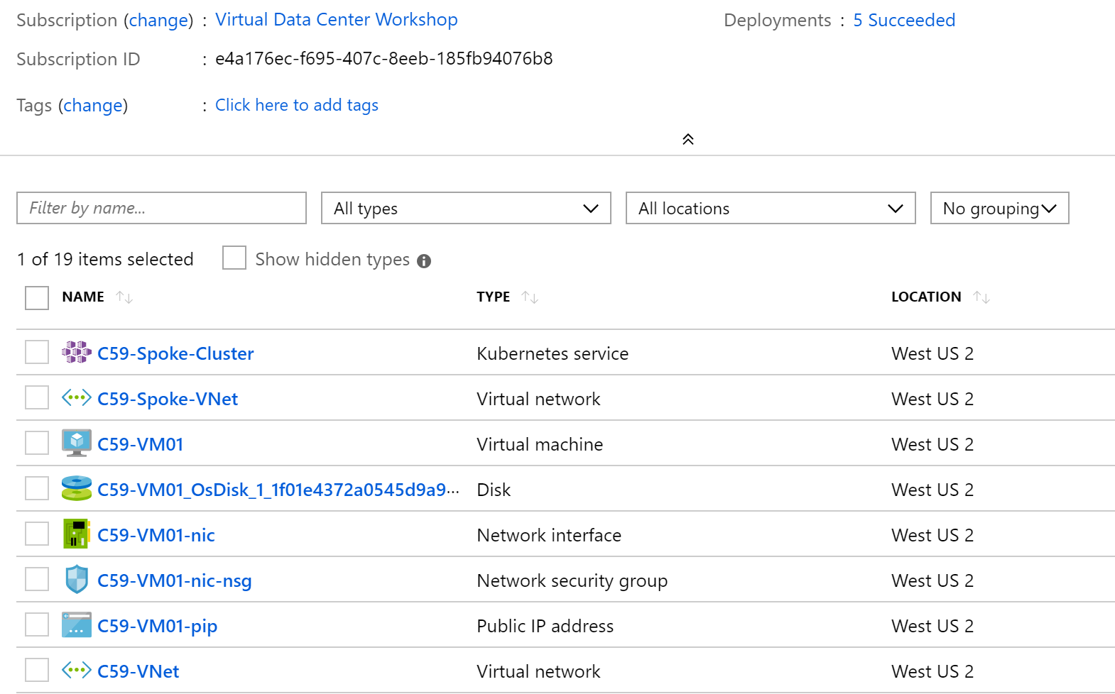

1. Create a Pod in your cluster to access the website from

Create an Alpine Pod and get shell access.

kubectl run samplepod --rm -it --image=alpine --generator=run-pod/v1

1. Get the IP Address of the VM

In the portal, click on the VM to go to the VM blade. You will find the Private IP on the blade. Make a note of it

Below is a sample for Company59

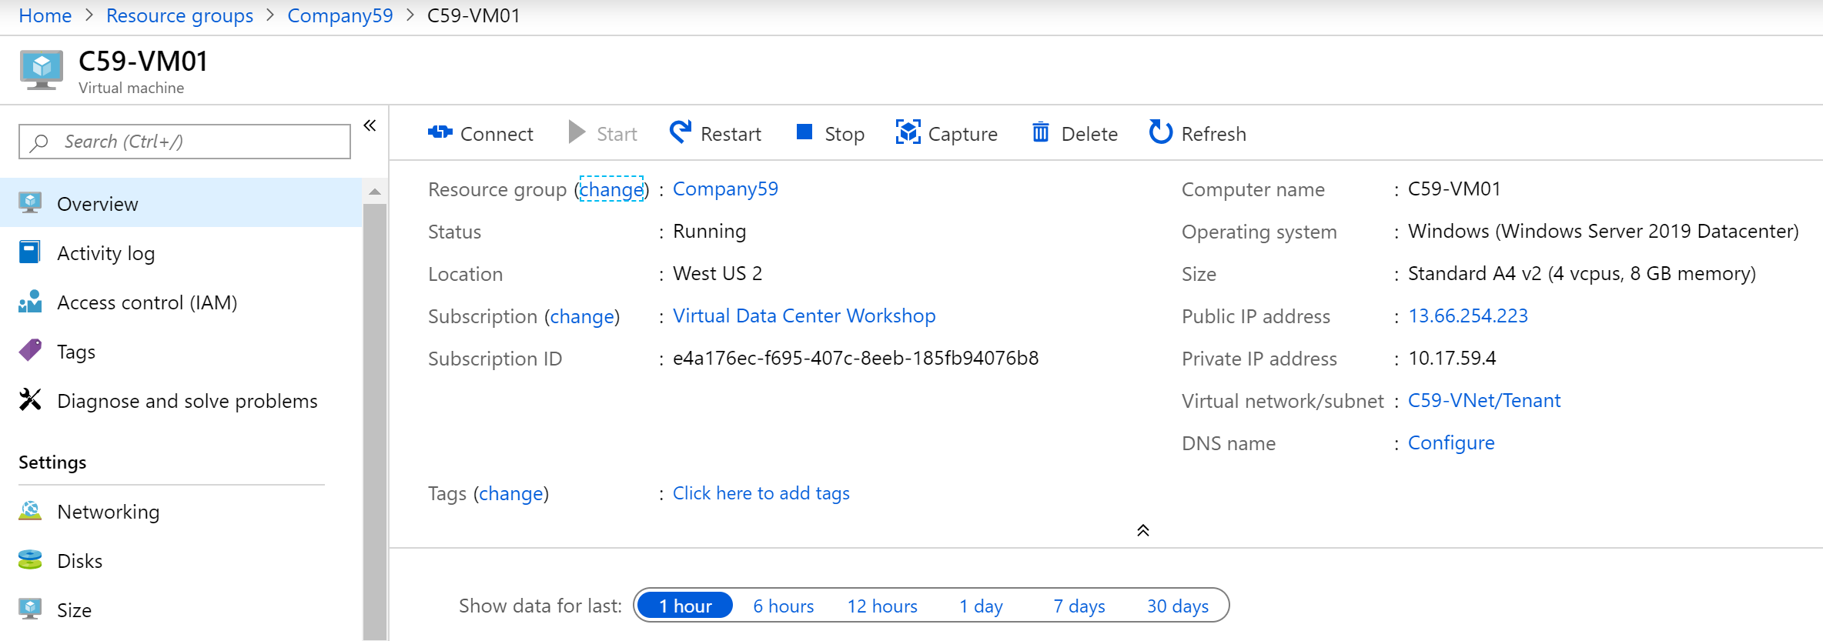

1. Access the website from this pod

wget downloads the http file of the website. Specify the IP address of the VM here.

wget -qO- http://<VM_PrivateIP>

1. Exit the Pod

This is done by typing “exit” at the shell prompt

## Accessing Storage Resource Protected by Service Endpoint

We will start by first creating a storage accounting and uploading a blob to it.

1. Setup a storage account and upload a blob

**Note: In all these commands replace ‘*’ with the company no.**

//Create a storage account

az storage account create -n c*aksstorage -g Company* --access-tier Hot --kind StorageV2 --sku Standard_RAGRS

//Create a storage container

az storage container create -n c*akscontainer --public-access blob --account-name c*aksstorage

//Upload a blob to this container

az storage blob upload -c c*akscontainer --account-name c*aksstorage -f ./blob.txt -n aksblob

//Generate a URL for the blob

az storage blob url -c c*akscontainer -n aksblob --account-name c*aksstorage

Make a note of this URL

https://c59aksstorage.blob.core.windows.net/c59akscontainer/aksblob

1. Access the blob URL from your browser

Observe that you are able to access the blob and view its contents

1. Setup ServiceEndpoint for your Storage Account

**Note: In all these commands replace ‘*’ with the company no**

// Configure ServiceEndpoint for Storage on your AKS cluster subnet

az network vnet subnet update --service-endpoints Microsoft.Storage -n Cluster -g Company* --vnet-name C*-Spoke-Vnet

// Tie your Storage to your AKS cluster subnet

az storage account update --resource-group Company* --name c*aksstorage --default-action Deny

az storage account network-rule add -n c*aksstorage -g Company* --subnet Cluster --vnet-name C*-Spoke-Vnet

1. Access the blob URL

Try accessing the URL from your browser and observe that you are denied access

Now access the same URL from your Pod using the following commands

//Create an Alpine Pod and get shell access.

kubectl run samplepod --rm -it --image=alpine --generator=run-pod/v1

//Access the blob URL from the shell

wget -qO- <URL>

1. Exit the Pod

This is done by typing “exit” at the shell prompt